The Irish Civil War 1922-23: Ava’s Diary – Teacher’s Notes

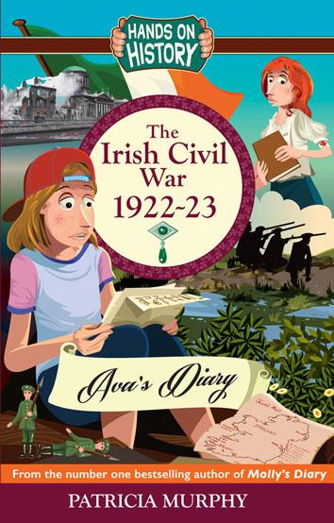

**Introduction**

How do you talk to children about the Irish civil war – or any civil war for that matter? It’s a difficult subject and still controversial today. The conflict still echoes down the decades, from the border with Northern Ireland to the origins of our main political parties. It was the baptism of fire for the new Irish Free State after the War of Independence and the 1916 Rising. Teaching 1916 in isolation is as senseless as talking about Henry V111 and stopping at the first wife. Teaching about conflict in the past helps children today get to grips with the world they will inherit from us. So it is vital for our understanding not just of Ireland today, but human nature and the challenges we face as a society.

My way of making the story fresh was to write a novel with a contemporary character, Ava who arrives from the United States with almost no knowledge of Irish history. We encounter the Civil War through the letters she finds in the attic of her rented apartment in Dublin and through her innocent eyes. This prompts an odyssey around Ireland to the major landmarks of the conflict.

Ava also faces conflict in her own divided family, echoing the theme of political division. En route Ava and her friend Mal learn all about the troubled history of the civil war. But also that conflict is also resolved in some ways over time. It becomes a personal journey of coming to terms with discord and strife of all kinds. So it is a story of hope and healing.

By lengthening the timeframe to the present, it allows us to show children that conflicts can find some sort of resolution even if imperfect. That we can learn from history to make a better tomorrow.

Ava’s Diary is my third novel about the Irish revolution. The main characters in the historical section, Molly, Jack the Cat, Anto and Dan were featured in the two previous novels. But it is stand-alone. Some children might have already read the previous novels and it will enhance their understanding but it isn’t necessary.

These notes are a guide to help you discuss the novel with the children. You can use them as a jumping off point for exploration. It suggests topics in line with the core curriculum. But they are only suggestions! Do move forward with any approach you wish!

The approach of these notes draws on the rich resource of the novel. It reflects the needs of delivering an integrated curriculum to explore the past from a range of perspectives. These include,

* Help with viewing history as an attempt “construct and interpret the past, rather than the past itself”. That it is a reconstruction based on informed historical research.
* Develop and practice investigation skills and understanding of primary and secondary sources.
* Develop an awareness of change.
* Empathy - Using stories to explore, imagine and discuss motives and feelings.
* Explore the perspective of a range of participants – women, men, and minorities.
* Explore complex events and questions through the eyes of believable characters.

The suggested study plan also reflect the practical requirements of the Core curriculum

* Encourage children to relate the historical period to their own family.
* Become aware of documentary resources, such as newspapers, Censuses, written accounts and learn how to extract information.
* Draw on visual sources to enrich understanding of the period.
* Relate personal and local history and reflect on change and continuity

For secondary level students using the novel as the basis for teaching can help

* Introduce children to the job of the historian by considering the wide tapestry of events
* Consider Irish history with objectivity and fairness
* Encourage critical and conceptual thinking about the way in which individuals and institutions influence and are influenced by the sequence of events in time and how the contemporary world is shaped by the past.
* Learn about the nature and use of historical sources.

The study plan follows a chapter-by-chapter structure with suggestions of exercises and projects to enhance both the understanding and enjoyment of history through stimulating exercises.

**SETTING THE SCENE**

-What do the children know already about the Civil War?

- What key facts do they know about 1916 and the War of Independence? (For example who the leaders were, the key events)

**The Book Cover**

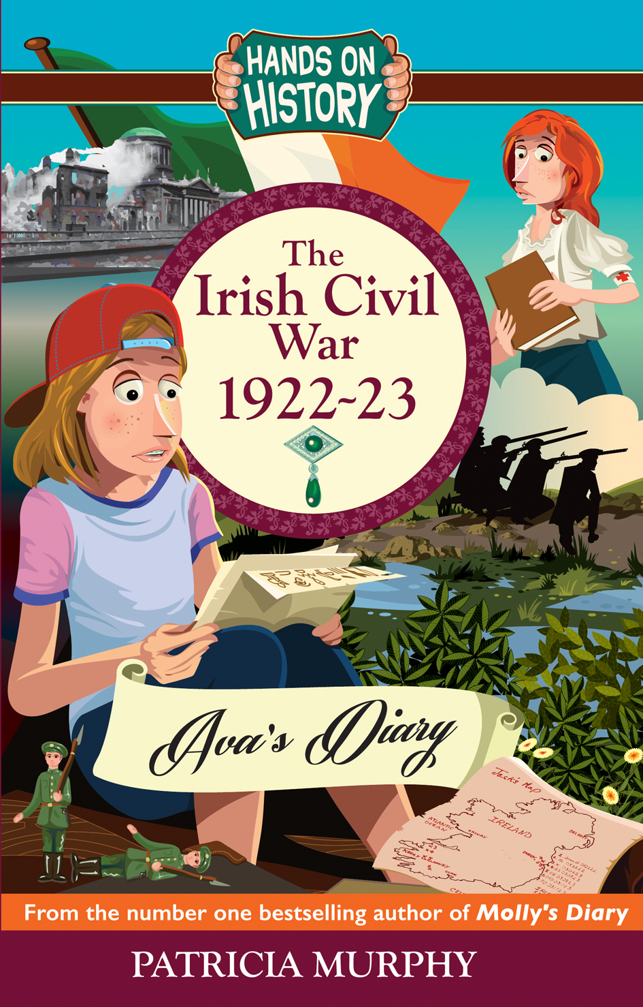

This book cover was chosen to appeal to a young age group.

What does the book cover tell you about the novel?

Can the class work out who is the main character?

Does the cover communicate the fact that Ava is a contemporary girl dealing with the past? What clues suggest that Ava is on a search?

Do the class recognize any of the other characters – for example Molly?

Is there anything on the front cover to suggest that this is a story about conflict and war?

Do you like the book cover?

What adjectives would you use to describe the mood of the book cover?

For example: exciting, lively, mysterious, tense, scary.

What about the expressions on the characters faces?

For example: uncertain, frightened, wondering, nervous, thoughtful, anxious.

Write down a sentence on what you think the book might be about just from looking at the cover.

…………………………………………………………………………………………

…………………………………………………………………………………………

From looking at the girl character, what do you learn about her character?

Why? Think about clothing, hair, expression on her face…

…………………………………………………………………………………………

…………………………………………………………………………………………

…………………………………………………………………………………………

Does the book cover give you an idea of historical period? For example, clothes, guns etc.

After they’ve read the book, would the class like to design their own version of the cover? Or Ava or any of the characters?

If yes – you are welcome to send to me to upload onto my website!

[www.patriciamurphyonline.com](http://www.patriciamurphyonline.com)

Can you work out from the front cover who writes the diary? Why do you think it is written as a diary?

Who is the author of the novel?

What *genre* is the novel in? This is a French word, meaning category.

Can you think of any other *genres* of writing? For example, biography, fantasy, graphic novels, women’s fiction, children’s fiction.

Chapter 1

**Summary: Setting the scene – Meeting Ava – Establishing the link to history of the Civil War through the letters.**

Ava finds scraps of letters from a mysterious letter writer in her fire grate and this sets up a mystery. The letter refers to events of the Irish Civil War, the quarrel between Michael Collins and Harry Boland over crown jewels; de Valera’s rejection of the treaty; the pogroms in the North of Ireland causing refugees to come south.

For each chapter the class can be asked to become Story Detectives and History Detectives. This allows them to go over what they have learned and how to approach the story.

BE A STORY DETECTIVE.

The first chapter is the scene setter. It establishes the time and place of the novel and the tone of the story. Ask the children to answer these questions, either written or in discussion.

|  |  |
| --- | --- |
| Who are the main characters telling the story in the present day? | Ava |
| Who is the mystery letter addressed to? | Sanjay |
| What are the names of the former best friends who are quarrelling? | Michael Collins and Harry Boland. |
|  |  |
| What is the mysterious letter writer studying? | Medicine |
| Where are all the old things the landlady’s husband kept? | The attic |

**FURTHER INVESTIGATION**

-Why do you think Ava is the main character of the story?

-Where is the story based?

-What is the mystery set up in the first chapter?

-What do you think of Ava?

-What adjectives would you use to describe Ava? Friendly, funny, a bit sad etc.?

Establish a character fact file on Ava – as if you were a police officer or her teacher!

|  |  |
| --- | --- |
| Ava’s age |  |
| Ava’s appearance |  |
| Ava’s mother |  |
| Ava’s father |  |
| Ava’s favourite activities |  |
| Ava’s home |  |
| Ava’s previous home |  |
| Ava’s current mood |  |
| Ava’s feelings about Dublin |  |
| Ava’s friends |  |
| Ava’s personality traits |  |
| Problems Ava faces |  |

Ava has moved from the United States to Ireland. She is still getting to grips with her new home and the differences between the two countries. For example, spelling is often different and sometimes different words are used. Ask the children to compile a list of words that are different in both countries.

|  |  |
| --- | --- |
| English term | American term |
| Rubbish | Trash |
| Lift | Elevator |
| Queue | Line |
| Trousers | Pants |
|  |  |

BE A HISTORY DETECTIVE

Ava finds some scraps of letters with some clues about the period of history and the historical narrative that will unfold. What have you learned so far? It doesn’t matter if you don’t know very much, just what can you work out from the context.

|  |  |
| --- | --- |
| What period of history are the letters set in? | Feb 1922, Ireland on the brink of Civil War |
| Apart from the Treaty what are Collins and Boland arguing about? | The Russian Crown Jewels |
| Who was the three-year guerilla war against? | The British |
| What is the name of the leader who the letter writer says of, the Oath sticks in his throat? | De Valera |
|  |  |

**Storytelling**

-Imagine you discover a scrap of paper or a secret letter in your house or garden from any time or era Write what is on it. It could be a map for buried treasure from the 17th century. Or a secret recipe from a famous cook in the court of Queen Victoria. Or even a threat or a begging letter or a confession. Use your imagination!

What era of history would you most like to find some documents about? Ancient Egypt? The United States during the time of the Wild West? The First World War?

**Tone and Voice**

Ava’s story is told in first person narrative. This means that the story is told to you by a character and is from one person’s point of view.

What is the advantage of having Ava tell the story?

-She is ignorant of Irish history and a newcomer and she sees everything with fresh eyes.

-She is young, like the readers so easier to identify with.

- We learn everything at the same time she does. Although sometimes she records something and we may see its significance before she does.

-We feel what she is feeling and it brings us closer to the action.

What other main ways are there of telling the story? Third person “omniscient” narrator, where the author, with Godlike powers, tells the story. Different first person narrators – switching between different characters points of view.

**THE DIARY FORM**

Ava records her thoughts and feelings in a diary or journal.

-Encourage the class to keep a journal for a week.

-Talk about other famous diaries – *The Diary of Anne Frank, The Diary of a Wimpy Kid, The Diary of Samuel Pepys, Princess Diaries* – see my articles for the Irish Times for more context on hooking children into history through diaries. <https://www.irishtimes.com/culture/books/dear-diary-patricia-murphy-on-hooking-kids-into-history-with-a-fictional-diary-1.2391758>

Chapter 2

**Summary – finding the letters: meeting a new ally: Northern Ireland**

Ava meets Mal who is from Northern Ireland and they find the old pile of letters, documents and the emerald broach in the attic.

BE A STORY DETECTIVE

|  |  |
| --- | --- |
| Where does Mal say he grew up? | Belfast |
| What was the name of the medical book they found in the attic? | *Delorme’s Book of War Surgery* |
| What was the date and big headline on the newspaper they found? | CIVIL WAR! |
| What kind of gemstone does Ava think they have found? | An emerald |
| What does Ava notice that Mal has around his ankle? | A bracelet like a tag |

Mal is a mysterious character who may or may not be a friend and ally for Ava.

Compile a fact file on Mal.

What adjectives or phrases would you use to describe him? Mysterious, prickly, funny, standoffish etc.

**Mal Fact file**

|  |  |
| --- | --- |
| Mal’s appearance |  |
| Mal’s age |  |
| Mal’s origins |  |
| Mal’s attitude to Ava |  |
| Mal’s mysterious bracelet around his ankle. What does that suggest? |  |
| Will Mal help Ava? |  |

**NORTHERN IRELAND**

Mal is from Northern Ireland. The fragment of the letter in the first chapter refers to events in Northern Ireland. So the theme of the situation in Northern Ireland has been planted.

See <http://www.bbc.co.uk/history/troubles>

**Further Historical Investigation– THE NORTHERN IRELAND SITUATION**

|  |  |
| --- | --- |
| What was the situation in Northern Ireland at the time of the Civil War in Ireland 1922-23? | The Protestants in the North wanted to stay part of the United Kingdom and did not support the idea of an Irish Republic.  Before and during World War 1 Protestant militias (small armies) had been formed to protest the North’s loyalty to the crown.  Many Protestants (and Catholics too) died in World War 1. The Protestants wanted the British government to keep them part of the United Kingdom. But the Catholics wanted Home Rule. Both sides were on a collision course.  During the Irish War of Independence, there were pogroms (violent attacks) against Catholics in the North. Hundreds of Catholics were murdered and thousands forced out of their jobs and their homes burned. Many fled down south. |
| What happened after the Civil War? | Six counties remained part of the United Kingdom. But the Catholics became a discriminated against minority. They didn’t get the same jobs or houses as the Protestant majority. In 1968 there was a Civil Rights movement. But the tensions in the North and the response of the British government led to an armed campaign. This let to “The Troubles” a period of violent conflict up to 1998  The Provisional IRA on the Nationalist side and the UDA and the UVF on the Loyalist side engaged in campaigns of murder and bombings There were attacks also in the south of Ireland and in Britain. Many people on both sides of all religions did not agree with using violence for political ends.  Over three thousand people died. |
| What is the situation today? | The six counties of Northern Ireland are still part of the United Kingdom. There was a guerilla war 1969-1998  The conflict came to an end with the signing of the Belfast Agreement, also known as the Good Friday Agreement.  This was voted on by people on both sides of the border. It was agreed that Northern Ireland would have its own devolved (separate) government and there would be “power-sharing”.  There are still problems in Northern Ireland but it is more peaceful today. |

Teaching about Northern Ireland can be difficult. But it is important for children to get to grips with it.

This history teacher had some ideas about how to bring it home to children. <https://www.theguardian.com/teacher-network/teacher-blog/2013/may/21/northern-ireland-troubles-best-history-lesson>

<https://www.youtube.com/watch?v=1kR11vn41XU>

is a relatively simple explanation.

You could also ask children if they themselves have any family relationship or direct knowledge of Northern Ireland. Obviously if reading in a school in the North, children will bring a whole different context to the discussion.

Chapter 3 –

**Summary– the author of the letters revealed. The background of 1916 and the War of Independence**

It is revealed that the author of the letters is called Molly and she has a brother called Jack the Cat. Readers of my previous novels *The Easter Rising 1916 – Molly’s Diary* and *Dan’s Diary – The War of Independence 1922-23* will already be familiar with Molly.

But from the brief clues so far what have we learned about Molly and her friends and family?

BE A STORY DETECTIVE

|  |  |
| --- | --- |
| What side does Anto support? | The anti-Treaty side – he is “all for a republic.” |
| What did Molly’s brother Jack gather funds for in 1916? | The Widows and Dependents Fund |
| What present does Sanjay send to Molly? | A beautiful embroidered Mexican shawl. |
| What is the name of Molly’s football mad cousin? | Dan |
| What job does Mal’s cousin Rachel do? | She is a jeweler. |
| What is the name of the semi-retired schoolteacher they meet at the library? | Betty |

BE A HISTORY DETECTIVE

Read the chapter and the rap poem carefully. Can you answer the following questions?

|  |  |
| --- | --- |
| What historical event happened in Ireland in 1916? | The 1916 Rising also know as the Easter Rebellion or the Easter Rising |
| What happened to the leaders? | They were executed and became martyrs. |
| Who led the guerilla war? | Michael Collins |
| Where did de Valera go to gather funds? | The USA |
| What settlement did Collins get in the Treaty? | A 26 county Free State not at 32 county nation |
| What happened as a result of the disagreements over the treaty? | Civil War |

**MOLLY’S LETTER**

We are getting to know Molly through her letters, which are also in the first person.

How would you describe the tone of Molly’s writing? Lively, fun, gossipy?

Does Molly seem mysterious?

Do you trust her?

How do you think Molly feels about her brother? Protective, worried etc.

Does Molly trust Sanjay?

What more are you learning about the Russian jewels?

In the library, Mal and Ava meet Betty the retired teacher who gives them a potted history of the Irish Revolution up to the foundation of the Free State and the Civil War.

Can the class perform the rap?

Can you write your own version? Or in another genre? For example as a series of tweets between De Valera and Michael Collins, a series of newspaper headlines.

Draw the events as a timeline or a cartoon strip.

CHAPTER 4

**Summary – Dealing with bullies, the Russian Crown Jewels and the Bolsheviks**

Ava and Mal encounter a group of class bullies as they go to the library. Betty the semi-retired schoolteacher digs out more information about the jewels that were in Harry Boland’s possession and came to Ireland. The look at his house in Marino Crescent. Rachel, Mal’s cousin reveals that the jewel they found in the attic is a genuine emerald.

The other girls are bullying Ava because she is different.

How do you think Mal and Ava handle the situation?

If you were in the same situation how would you react?

Mal and Ava learn that the Irish delegation in the United States became friends with the Russian Bolsheviks. What can you find out about the Russian Revolution of 1917, the Bolsheviks and the Czars of Russia?

See for a simple account <https://www.youtube.com/watch?v=KOK1TMSyKcM>

<http://www.ducksters.com/history/world_war_i/russian_revolution.php>

What are the main differences between the Irish and the Russian revolutionaries approaches to gaining freedom?

Russia was a much bigger country, with bigger divisions between rich and poor. The serfs were little more than slaves.

The Russian Bolsheviks were prepared to seize power. While the Irish used military means to fight for freedom, the majority believed in democracy to support their aims.

What happened to the Czar and his family?

**Chapter 5 and Chapter 6 –**

**Summary – searching for the jewels, unraveling the codes to the letters**

Ava and Mal travel into town and meet Rachel in her studio to learn more about the jewel. While there, they encounter the mysterious Russian that they saw in the library. They agree to let her new boyfriend Patrick, a research mineralogist to examine it. They visit the museum at Collins Barracks and learn how documents were smuggled in books. They discover a stash of documents and letters written in code in the *Delorme’s Book of War Surgery*.

They read the first letter from Sanjay and discover the existence of a second set of jewels and that Jack the Cat; Molly’s brother is going to dive for them near the statue of Liberty in New York Harbour. They enlist the help of others to help de-code the letters.

BE A STORY DETECTIVE

|  |  |
| --- | --- |
| Where is Rachel’s studio? | Merchant’s Alley near the Ha’penny Bridge in Dublin |
| What is a mineralogist, the job of Patrick, Rachel’s boyfriend? | Someone who researches minerals and their properties. |
| What do Sanjay and Jack propose to do? | Dive for the other mystery jewels in New York Harbour. |
| What do we learn about Anto? | That he has got married. |
| What are ciphers? | Secret codes substituting symbols for letters. |
| What are Sanjay’s connection to the Russian spy Borodin and the jewels? | His cousin Roy in Mexico City where Borodin stayed. |

BE A HISTORY DETECTIVE

|  |  |
| --- | --- |
| Where did the crown jewels remain until de Valera came to power? | Up the chimney of Harry Boland’s mother in Marino Crescent, Clontarf, Dublin |
| What was the name of the real life Russian spy? | Borodin |
| What is the Bolshevik mission? | To spread armed revolution around the world |
| What are some of the wild stories circulating in the United States about the fate of the Russian jewels? | That they were smuggled out of Russia in coffins or hidden in the Gobi desert. |

**SMUGGLING DOCUMENTS**

Smuggling information and letters is not just the stuff of Bond movies but part of the everyday job of spies and villains.

What can you learn about how documents were smuggled in the Irish War of Independence and the Civil War? For example, in baby’s prams. Inside false linings of jackets. In the tops of women’s stockings. In hidey-holes in walls.

Can you think of good places?

If you were smuggling today, where would you hide documents and information?

**DESCRIPTION**

When Ava talks about the rain she uses a number of adjectives, similes, metaphors and verbs.

Can you think of good descriptions for the rain? Or for snow, wind, sunshine.

**CHAPTER 7**

**Themes** – **The Four Courts on the brink of Civil War – The Republicans**

Molly in her capacity as a medical student visits Anto who has joined the anti Treaty forces in the Four Courts. They have a long discussion about the arguments for and against the Treaty. Molly begins to realize the seriousness of the threat of war.

BE A STORY DETECTIVE

|  |  |
| --- | --- |
| What is Anto’s mother’s name and Molly’s family former charlady? | Nancy |
| What happened to Anto’s big toe in 1916? | It was amputated by Dr. Ella Webb |
| What does Anto give Molly for his wife Sinead? | A locket |
| What job is Anto’s sister May doing? | Chambermaid in a hotel near the Four Courts |
| What is Anto’s task in the Four Courts? | As a former grocery delivery messenger, he is in charge of provisions |

BE A HISTORY DETECTIVE

|  |  |
| --- | --- |
| Where was the Headquarters of the anti-Treaty forces? | The Four Courts |
| How many rebels were occupying the Four Courts? | Fewer than 200 |
| What was the name of one of the leaders, a former medical student? | Ernie O’Malley |
| What boy scout troop led by Countess Markievicz took part in the occupation? | Fianna boy scouts |
| What were they using to barricade windows? | Piles of books from the Public Record Office and other old manuscripts and journals. |
| What was the name of the son of one of the leaders who was executed in 1916 | Sean MacBride |

The anti-Treaty side made their Headquarters in the Four Courts.

What can you learn about the Four Courts during the Civil War?

Who were the leaders there?

Was it a good choice?

What was the response of the newly formed Free State government?

What do you think of the response of Nancy’s family? How do you think ordinary people responded to the outbreak of war again?

Anto and his brother end up on different sides. Can you think what the consequences of this might be – how families were torn down the middle?

CHAPTER EIGHT

**Summary: Conflict in Ava’s own life, the attack on the Four Courts: The Women’s peace initiative: The hardening of positions on both sides.**

Ava’s own family is beginning to fall apart. Her father wants to divorce her mother. Concentrating on what was happening in the Irish Civil War helps Ava escape her own problems.

This chapter also features the dramatic events on the attack and destruction of the Four Courts. Molly presents an eye witness account, much of which is based on historical research.

BE A STORY DETECTIVE

|  |  |
| --- | --- |
| Who was the sniper that Molly saw escape? | Anto |
| Who did he shoot dead? | His own brother Jemsie who was fighting on the Free State side. |
| What does May remove from Jemsie’s pocket? | A photo of their mother Nancy. |
| Where is Patch, the boy Molly meets escaping from the Four Courts, originally from? | Macroom in County Cork. |
| Who does Molly meet at the Hamman Hotel, who she knew from Mountjoy Jail? | Nurse Linda Kearns |

BE A HISTORY DETECTIVE

|  |  |
| --- | --- |
| What was the reaction of some of the people of Dublin to the bombings? | They lined the streets to gawp. |
| What was the name of the 25-year-old second in command to Michael Collins who had to man the Free State guns himself? | General Emmet Dalton |
| What is blown up from the Four Courts, rising on a column of smoke? | The central green dome. |
| What else rains down on the city of Dublin? | Documents and papers from the Public Record Office. |
| What are the names of the two women Molly meets that have set up the Women’s Peace Delegation? | Maude Gonne McBride and Charlotte Despard |
| What members of the Free State government does the Women’s Peace Delegation meet? | Michael Collins, President Arthur Griffith, Cosgrave |

**The Bombing of the Fourt Courts**

When I am writing, I am very influenced by photographs from the period. I feel they give a real flavor and help me imagine what it must have been like to be in the heart of something as momentous as the bombing of the Four Courts.

Below are a series of still images” spectators gathering on the Quays, the mushroom cloud of smoke as the dome is bombed, a sniper at a window.

Imagine you are part of the scene and tell the story from your point of view

* A bystander
* -A sniper for the “Irregulars”
* -A Free State recruit manning a gun
* -An ambulance or First Aid worker.
* What do you see? Describe what happens. How do you feel? Are you scared? Angry, curious? What does it sound like? Do you get covered in dust and find it hard to breathe? What is everyone around you doing?
* Pretend you are a reporter for a newspaper or a newsreel. How would you report the scene?
* 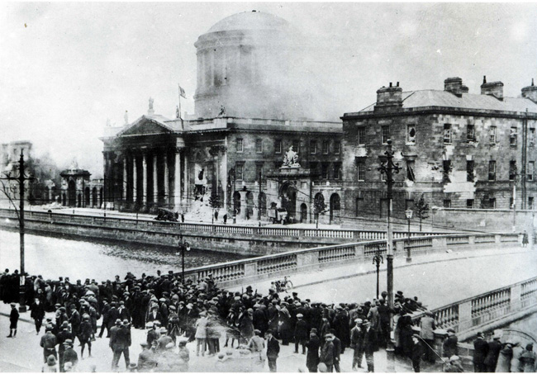 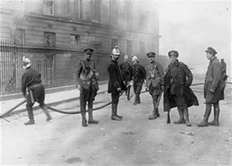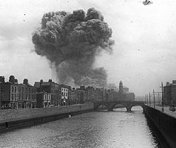 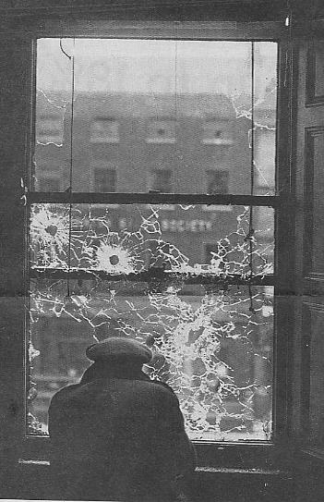

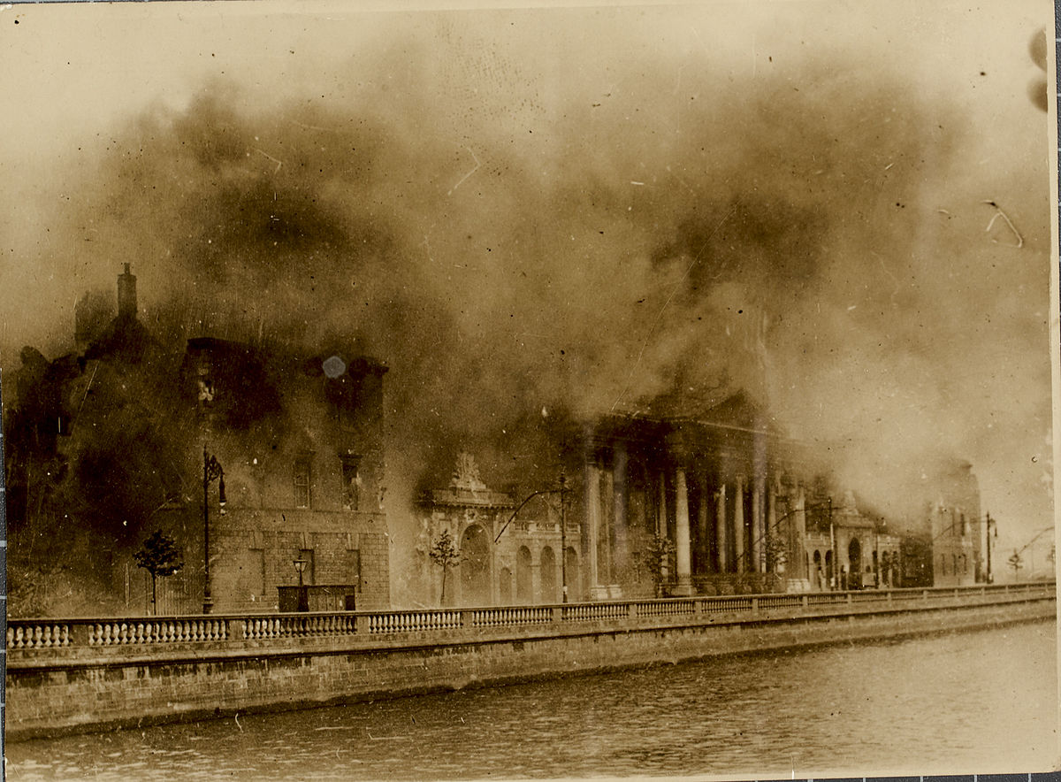

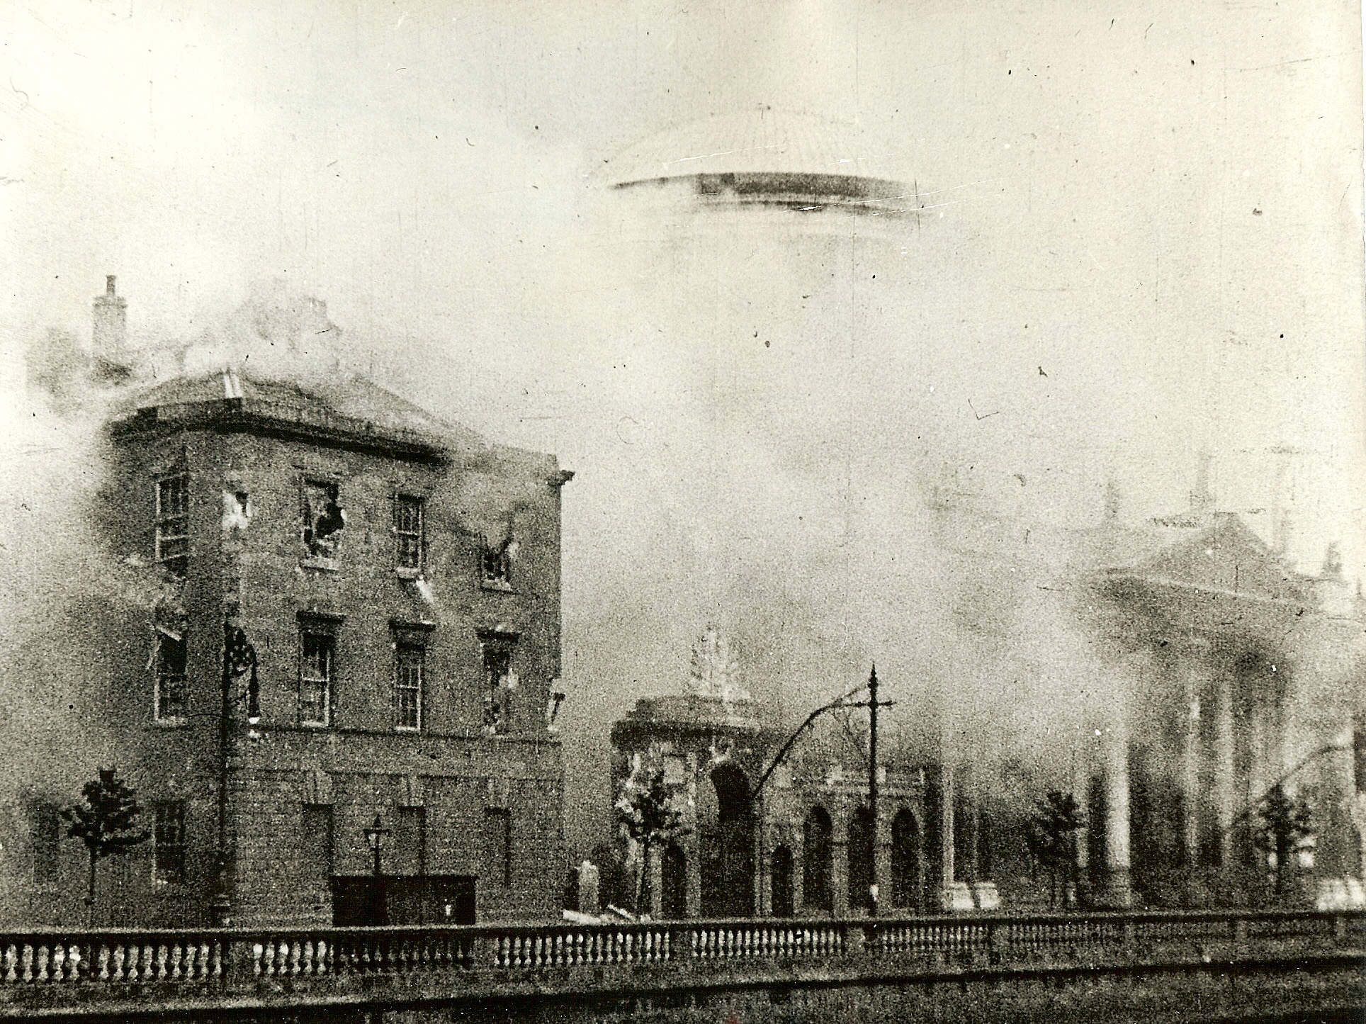

Ava and Mal see a demonstration against the Civil War in Syria. This is a major civil war that is happening in our own time.

-Find out what you can about the Civil War in Syria. Who started it? Who is fighting who? How many have been killed? How is it affecting children? Many refugees have had to flee to Europe. What has happened to them?

Can you find out how many wars and civil wars are happening today.

Ava worries about pets and animals caught up in the Civil War in Syria. Write a little story about a cat or a dog caught up in a war. You could write it from the point of view of the animal!

**Chapter 9 and Chapter 10**

**Themes** – More information about the jewels: The Battle on Sackville Street: the death of Cathal Brugha: the aftermath of the Battle of Dublin

In Chapter 9 Ava and Mal get more detailed information from Patrick, the minerologist about the Crown Jewels. While Harry Boland really did Crown Jewels back to Ireland, I invented the storyline about the second set of crown jewels brought to Ireland by Jack. However, the lost emerald necklace and the discovery of the photograph in the American geology library is based on fact. To this day, not all the Russian crown jewels are accounted for.

BE A STORY DETECTIVE

|  |  |
| --- | --- |
| Where was the emerald from? | Muzo in Colombia |
| What famous jeweler does Rachel think made the necklace? | Tiffany |
| What do Ava and Mal set up in their attic? | An incident room. |
| Who helps them with the Green translation? | Old Mr. Stavros |
|  |  |

BE A HISTORY DETECTIVE

|  |  |
| --- | --- |
| What is the name of the young student Molly meets fighting for the rebels in the Block? | Todd Andrews |
| What is the name of the new fangled shot gun he has? | Thompson Gun |
| What is the name of the famous martyr of the War of Independence, whose sister Kathy is in the Gresham? | Kevin Barry |
| What does Cathal Brugha shout as he comes out of the building? | No Surrender! No Surrender! |
| Does his death bring an end to the conflict? | No, the Civil War continues down south. |

**Cathal Brugha**

Cathal Brugha was a famous hero of 1916 and the War of Independence who took the anti-Treaty side in the Civil War. What can you find out about him?

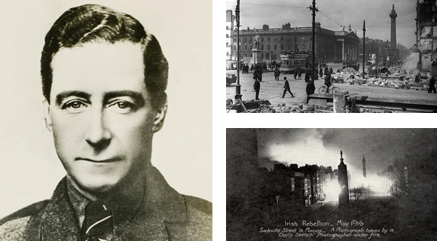

See - <http://www.easter1916.ie/index.php/people/a-z/cathal-brugha/>

**Setting up an Incident Room**

Ava and Mal set up an Incident Room. You might have seen these on Crime Dramas. It means putting up information about an “incident” or series of crimes.

Have a go with the class creating an incident room on Ava’s Diary.

You could do one on the characters in the book – Ava, Mal, Betty in the present. Molly, Jack and Sanjay in the past. Draw pictures of them and plot out the mystery.

Then have another one with a timeline of the Civil War. Putting up information and characters from the real Civil War.

Chapter 11

**Summary:** The Return of Jack – difficult news for Ava

We learn from Sanjay’s brief letter that Jack is on his way back. But also in the present day, Ava learns that her former nanny Honey Belle is to become her new step-mom. Even though this is a short chapter, these developments represent turning points in the historical narrative and also in the present story of Ava.

Be a Story Detective

|  |  |
| --- | --- |
| What makes Ava and Mal think the letter might have been written by Sanjay? | The watermark of the Crowne Plaza Hotel NY on the paper |
| According to Sanjay, what does Jack plan to do with the jewels? | Jack believes emeralds to be a healing stone. He thinks if he brings the new jewels to Harry Boland, he can try again to present them to Michael Collins as a peace offering. |
| What are Gandhi’s ideas about passive resistance mean? | A whole country refuses to co-operate with an alien power. |
| What has Jack learned from Native American tribes | About the peace pipe and the dances of peace to the sun. |

**The Return of Jack**

What have you learned about Jack from Molly and Sanjay’s previous comments in the letters? (That he was a hero of 1916, a daredevil, he has worked in the circus, he is charming and fun and a bit wild)

What do you think of Jack’s ideas in the situation of a Civil War? Is there much hope he would succeed?

What do you think will happen now that Jack is back in Ireland? Who will he try to contact? What effect will this have on Molly?

What about how Ava is feeling about her news? How is Ava handling this new piece of information? Does she feel betrayed?

Do you think there are any parallels in what is happening in Ava’s life and what is happening in the historical narrative? (Feelings of betrayal, not knowing whom to trust, anger on both sides)

**Chapter 12**

**Summary:** the effect of the Civil War on ordinary people, the rocky reception of the Women’s Peace rally, the death of Harry Boland.

Rather than ending the hostilities, the defeat in Dublin of the anti Treaty sides leads to a hardening of positions and the war moving down south. The Women’s Peace rally has little effect. The assassination of Harry Boland increases the distrust and bitterness between both sides.

**The Effect on Nancy’s family**

With all the bombings and destruction, May has lost her job. Nancy suffering from poverty and grief over the death of her son becomes ill. There is also bad feeling between them and Anto’s wife Sinead.

**The Death of Harry Boland**

Harry Boland was a major figure in the War of Independence. What can you find out about his life?

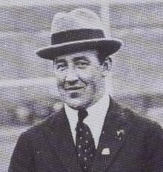

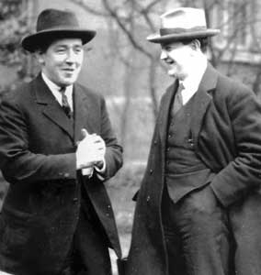

Harry Boland and Michael Collins pictured here used to be best friends. Discuss how the Civil War split many families and friendships. This is what makes Civil War so bitter, it divides people who usually get along well and love each other, like neighbours and friends.

Ava is also experiencing splits in her family. She feels angry with her father.

Ask the children to reflect on how they are learning to resolve disputes and arguments. And why it is a good idea to settle disagreements before they go too far.

Molly and her brother Jack are re-united. They have a different experience. How do you think both of them felt about the meeting after six years of separation? Do you think Jack will listen to what Molly says? Do you think Jack understands that Anto has now become a hardliner?

BE A STORY DETECTIVE

|  |  |
| --- | --- |
| What illness does Nancy have? | Acute bronchitis |
| What nicknames does Nancy use for Maud Gonne MacBride and Charlotte Despard? | Maud Gone Mad and Charlotte Desperate |
| What kind of necklace is May concealing? | A blue sapphire |
| Where does Molly meet Harry Boland? | Glasnevin Cemetery |
| On what condition does Jack say he’ll go back to the United States? | If Anto needs to escape the war and comes with him. |

**Chapter 13**

**Summary**: breakthrough with what happened to the jewels through scientific analysis. Patrick’s laboratory makes discoveries that suggest the jewels were exposed to rough treatment.

BE A STORY DETECTIVE

|  |  |
| --- | --- |
| What metal the settings and chain links of the jewel made of? | Platinum |
| Who did Mal see going through Trinity College’s main entrance? | The Russian |
| What does old Stavros call Molly? | The dove among the crows of war. |

**The “Russian”**

Ava and Mal keep seeing this mysterious man who they nickname the Russian on their tail? What do you think he is up to? Do you think it’s their imagination or is he really following them? Draw a picture of what you think he looks like from other clues in the book.

**CHAPTER 14 –**

**Summary**– The return of Jack: Meeting with the Belfast refugees and Countess Markievicz at the Kildare Club: The Fianna Boys hiding out in the Dublin mountains: Anto’s increasing hardline position.

Jack, Molly and May go to the Kildare Club, the fanciest Men’s club in Dublin, where refugees have been billeted. They begin to understand the suffering of families in the North of Ireland. They also encounter Countess Markievicz, who is strongly anti-Treaty. Jack’s unusual position and the influence of ideas about bringing peace becomes more apparent. Jack’s activities become mysterious again and Molly has a difficult meeting with Anto in the Dublin and Wicklow mountains. Anto’s distrust towards Jack plants the suspicion in Molly that Jack might be a spy for the Free State side.

BE A STORY DETECTIVE

|  |  |
| --- | --- |
| What is Nancy’s nickname for Countess Markievicz? | Countess Marzipan |
| Where do Molly, Jack and May visit the refugees from Belfast? | The Kildare Club |
| Who made Jack’s peace pipe? | The Cherokee native Americans |
| What does de Valera’s Native American nickname mean? | Dressing Feather |
| What was the code word for Anto’s hideout? | Marino Casino |
| Where is Anto planning to go? | To the heart of what he calls, The Munster Republic |

BE A HISTORY DETECTIVE

|  |  |
| --- | --- |
| Why did families flee Northern Ireland? | Because of the “pogroms” – attacks on their homes and killings. |
| What side did Countess Markievicz support? | The anti-Treaty side |
| Who was the Indian leader of passive resistance that Jack admires? | Gandhi |

**TO EXPLORE**

Thousands of families left Northern Ireland due to violence and danger during the War of Independence and Civil War. Find out more about their story.

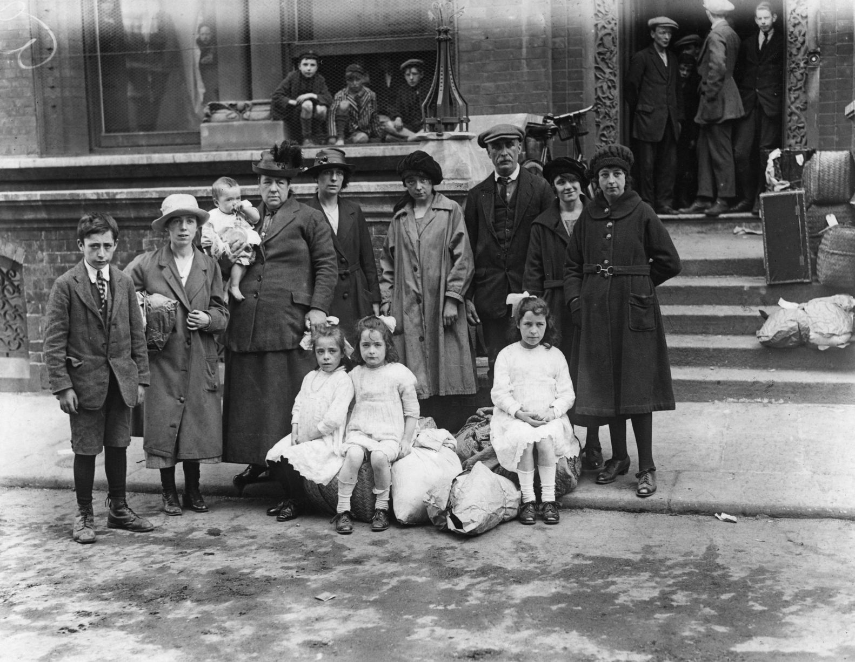

This is a picture of a family outside the Kildare Club – exactly like in the story where the refugees were put up.

What do you think the little girls are feeling and thinking? Or the boy on the left? What about the three boys in the window behind? Do you think they would be mischievous?

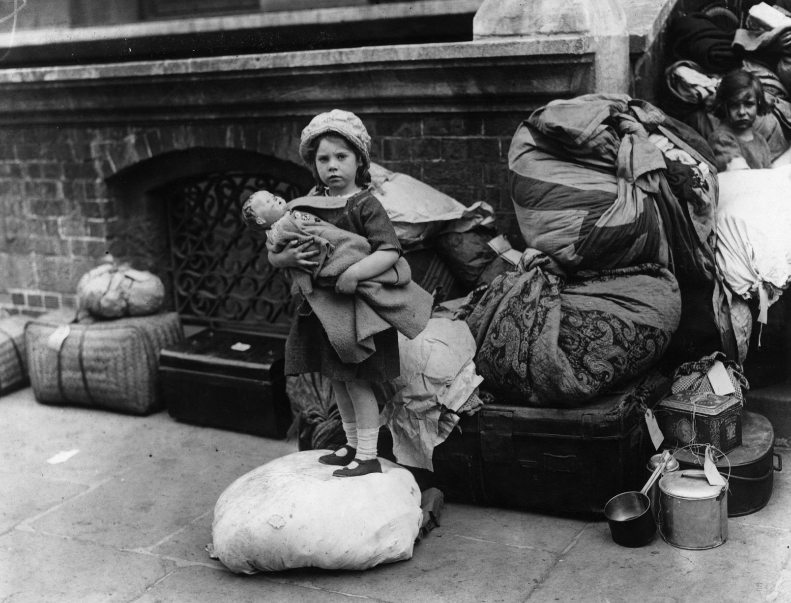

What about this little girl? Imagine a conversation between her and her doll. Imagine what it is like to be a refugee. Having to leave your home and neighbourhood for an uncertain future. What would you take? How would you feel about the people making you leave your home? Can you find another little girl in the photograph? She doesn’t have a lovely doll. What do you think she might be feeling and thinking? Do you think she would be envious of the little girl with the doll and nice clothes?

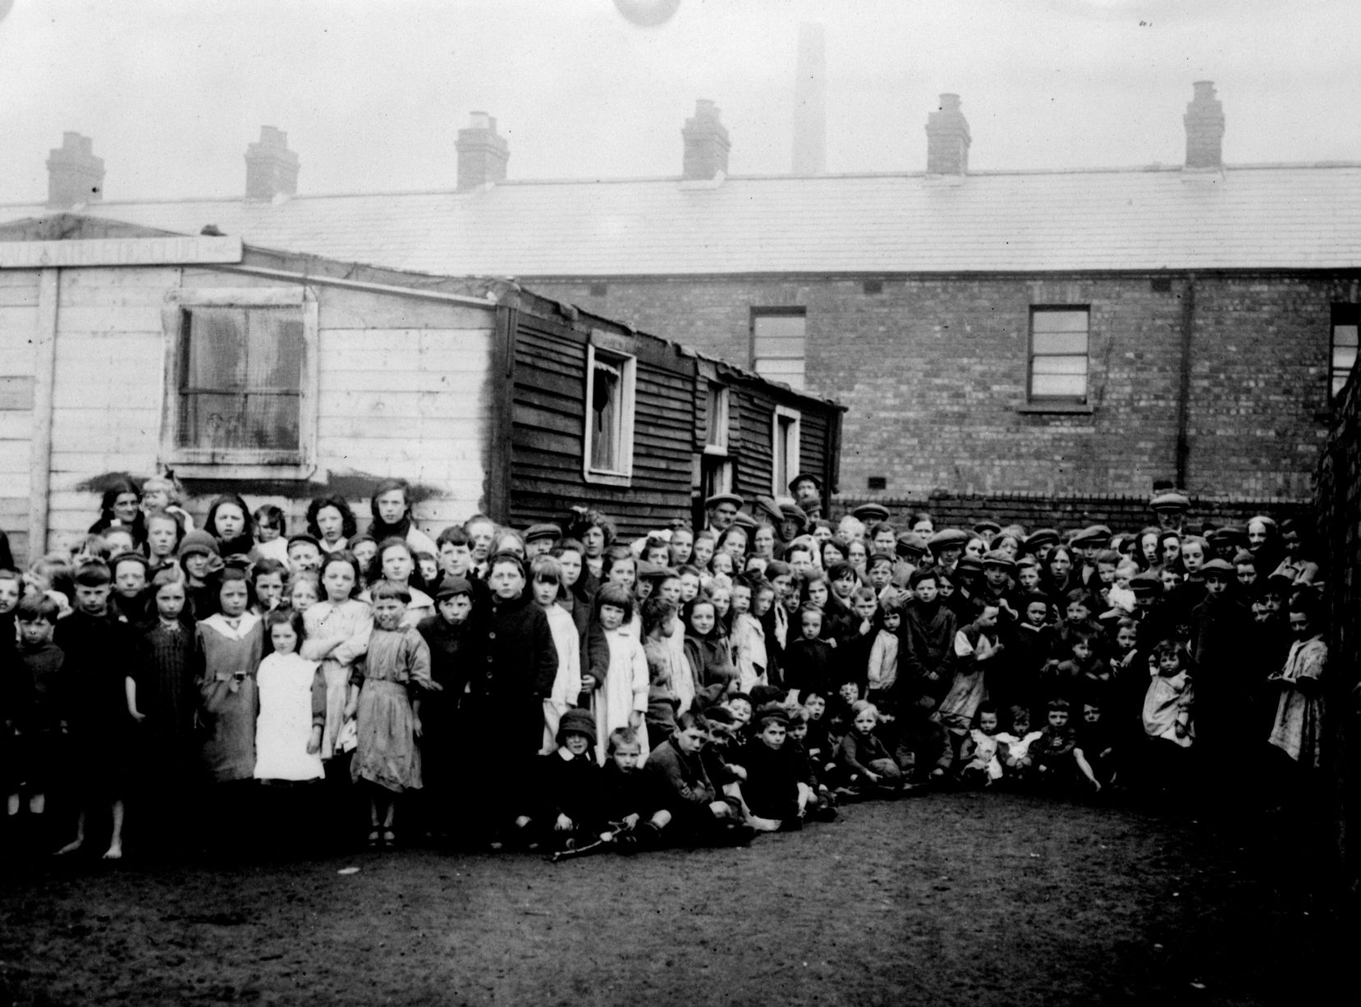

Look at all these children. What do you think they are thinking and feeling? Sad, lonely, maybe even a bit excited?

Anto thinks Jack might be a spy and plants that suspicion in Molly. What do you think? Do you think Jack’s talk of peace pipes is a cover for spy activity?

TO EXLORE.

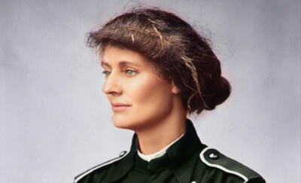

Countess Markievicz was one of the heroines of 1916, the first woman ever elected to British parliament, even though she didn’t take her seat. Find out about Countess Markviecz. Why did she support the anti-Treaty side, do you think?

**Chapter 15**

**Summary**: Cracking codes in the letters: moving to County Cork and the thick of the Civil War. The death of Michael Collins. The revelation about how the jewels were damaged.

This is a very dramatic chapter with an account of what is perhaps the most controversial event ever in Irish history – the death of Michael Collins. Molly’s eyewitness narrative is based on real accounts of what happened on that fatal day at Beal na mBláth. In the fictional narrative, we also learn about what happened to the jewels; that Jack shot them up in grief at the fate of Collins.

BE A STORY DETECTIVE

|  |  |
| --- | --- |
| Where are Molly and Dan staying in County Cork? | Kilbritain County Cork |
| What new skill has Molly learned? | How to drive. |
| What was the name of the patient Molly went to see near Beal na mBláth? | Deirdre |
| What does Jack do with the Emerald necklace? | He shot it to smithereens. |
| What are Ava and Mal planning to use to try to locate the other jewels? | A metal detector. |
|  |  |

BE A HISTORY DETECTIVE

|  |  |
| --- | --- |
| What was the name of the pub where Michael Collins met his relatives? | The “Four Alls” in Sam’s Cross. |
| Why did Collins and his team come through Beal na mBláth the first time? | Because a stretch of the main road was blown up between Bandon and Macroom. |
| What was the weather like when Michael Collins was shot? | It was foggy. |
| Why did Collins believe he would be safe? | He did not believe anyone would kill him in Cork, his own part of Ireland. |
| Why did no one know who fired the fatal shot that killed Collins? | The twelve anti-Treaty rebels in the ambush swore an oath of secrecy never to reveal who fired the fatal shot. |

**The Death of Michael Collins**

Can you find out more about this event?

Do you think they meant to kill him or was it an accident?

What effect do you think it had on the Civil War? Do you think it made everyone so angry and sad, the Free State side wanted revenge?

**Cracking Codes.**

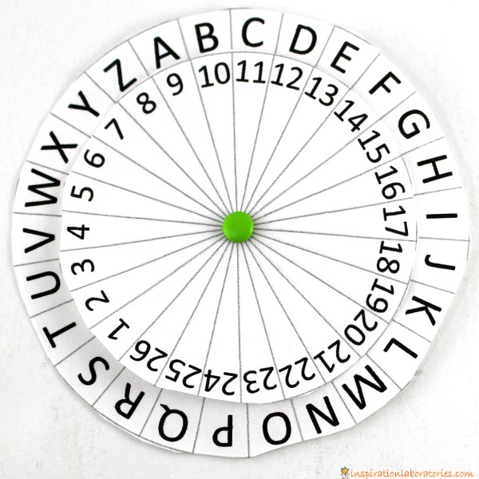

Mal shows a talent for cracking codes and working out ciphers. This is a number wheel. Make your own and send messages to each other. Can you devise your own secret code?  
For more information - <http://inspirationlaboratories.com/secret-codes-for-kids-3-number-cyphers/>

<https://www.brent.gov.uk/media/387164/Take%20One%20Letter%20spy%20code%20resource.pdf>

There are also some good ideas for simple codes here: <https://kidsactivitiesblog.com/27282/secret-codes-to-write-a-coded-letter>

<https://www.melissaanddoug.com/blogpost?postId=6-secret-codes-for-kids>

<https://www.pinterest.co.uk/explore/secret-code/?lp=true>

**Chapter 16**

**Summary**: Mal and Ava find the map, unlocking the key to where the jewels might be buried. They also learn more about atrocities committed during the Civil War.

Ava and Mal agree to go to Kerry. The map they find has clues, which they realize reveal the hiding places of more jewels. They discover a jewel on the site of the monument to two young Fianna men who were murdered in Dublin in revenge for the death of Michael Collins. The Russian gives chase to Ava, acting as a decoy. But she makes it safely to the library.

BE A STORY DETECTIVE

|  |  |
| --- | --- |
| What is the name of Ava’s mother’s friend who she will stay with in Kerry? | Nora |
| What is the first jewel concealed in? | A tin soldier |
| What kind of car does the Russian drive? | A Nissan Micra |
| The sight of what bird cheers Ava up? | A robin |

BE A HISTORY DETECTIVE

|  |  |
| --- | --- |
| Where did Michael Collins body lie in state? | City Hall |
| What were the names of the two murdered in Yellow Lane, Whitehall, North Dublin | Sean Cole and Alf Colley |
| To what Youth Organisation did they belong? | The Fianna |
| What is the name of the new general who succeeded Collins | General Mulcahy |

Draw a picture of what you think the map might look like.

The jewel was hidden at a monument in Yellow Lane in Whitehall. You can still see the monument

See <https://comeheretome.com/2016/11/21/colley-cole-and-murder-at-yellow-road/>

There are hundreds of monuments all over the country to events and people during The Irish Revolution from 1916 to 1923. Also to those fallen in World War 1. Can you find any in your local area?

Why do you think people put up monuments?

Do you think they are helpful in remembering the past?

Design your own monument to innocent children who are killed in wars, either in Ireland or anywhere in the world.

**Chapter 17**

**Summary**: on the trail of the jewels in Cork and Kerry: the war down south

Ava and Mal head to Munster on the trail of the jewels and learn more about the Civil War down south. Molly stays with a family in Knocknagoshel and encounters suffering and danger first hand. They learn about Jack’s tense encounter with Anto and after hostilities become friends again. Anto discovers that the sniper he killed was his brother. Anto and Jack have to go on the run together. Mal and Ava visit Beal na mBláth and find another jewel.

This chapter moves to Cork and Kerry where the Civil War was particularly bitter. The complexities of allegiances and the shifting nature of a guerilla war are explored through the actions of Anto. We learn also of some of Jack’s small gestures of defiance, replacing ammunition with roses in guns for example.

BE A STORY DETECTIVE

|  |  |
| --- | --- |
| Where does Molly go to live in Kerry? | Knocknagoshel |
| Where is Anto hiding out? | The Clocha Liath – “Grey Stones” fairy fort in the mountains |
| How does Anto escape? | He jumps out he window of the ruined castle |
| What is the other name for phosphorescent light from the decaying mushrooms? | Foxfire. |
| In what year was the monument put up to Michael Collins? | 1924 |

In this chapter Anto has to confront the consequences of his actions and decisions. His humanity shows through in the fact that he could not kill Jack or Molly.

Do you think Anto would have shot his brother is he knew it was him, even though he was on the other side?

Is Jack right in thinking that Anto will never kill again?

Do you think Anto shows remorse and feels guilty about his acts?

How do you think Anto will change now, as Jack believes?

There is good advice here for talking to children about war and violence.

<https://www.commonsensemedia.org/blog/explaining-the-news-to-our-kids>

Also here about introducing children to philosophical and critical thinking.

<https://plato.stanford.edu/entries/children/>

Even very young children are capable of sustained and sophisticated critical thinking. They are encountering new ideas every day and look at life with fresh eyes. There are no easy answers but it’s important to encourage the children to start thinking about these subjects. And help them realize that as a species, humankind is on a journey to find better ways of resolving conflict.

When talking about war, you can begin by pointing out that wars and violence are as old as the human race. Generally we believe that “thou shalt not kill.” But some people resort to violence as a way of imposing their rules, power and ideas on everyone else. Very often ordinary people find themselves at war because of decisions taken by political leaders. They don’t have much say in the matter. But at the same time some people believe we need armies and to fight at times to stop other countries or small groups of terrorists bullying us. Other oppressed groups feel that violence is sometimes the only way to make society change.

The danger is this leads to a spiral of violence, a tit-for-tat with lots of innocent people getting hurt. Even in war there are rules, mostly aimed at trying to prevent innocent people being hurt. But it is not easy to police. Some people thinks some wars are just wars – such as World War 2 against the Nazi’s in Germany who wanted to eliminate Jewish people, disabled people and gypsies because they thought they were inferior. Some people think wars to stop genocide – that is trying to kill a particular group of people because you just don’t like them – such as what happened in Serbia and also now in Burma, are justified if it’s the only way to stop the killing.

Civil Wars always feel particularly tragic because it is friend against friend, brother and sister and against brother and sister. In Irish, the Civil war is known as “Cogagh na Cara” the war of friends. Families are torn apart, people who even once saved each other’s lives, become sworn enemies. In Ireland, Erskine Childers, an anti-Treaty supporter was executed for carrying a pistol that had once been a gift from Michael Collins. In the Cork family, one brother Sean Hales was assassinated for being a Free State T.D. His brother was part of the unit that killed Michael Collins in Beal na mBláth. Kevin O’Higgins signed the death warrant to execute Rory O’Connor, who only a year before had been the best man at his wedding. Kevin O’Higgins was assassinated by Republicans five years later.

This level of division causes lasting bitterness and pain that can trap a society for generations. Can you think of other countries where Civil War has caused many problems? For example, the United States, Spain, The United Kingdom.

How can societies heal these divisions?

The main challenge we face is trying to resolve conflict first by peaceful means. Then if war breaks out, trying to find ways to end it and restore peace and justice. That is why we have organisations such as the United Nations and

In the Civil War in Ireland, because everyone had been fighting for so much time and there were so many guns around, events quickly turned to war. Like many young men Anto had grown up around guns and war. Do you think it is understandable that he became a rebel fighter?

Jack is interested in other ideas – such as passive resistance and acts of sabotage. He also puts himself in danger. What do you think of his ideas?

What about Molly? She has grown up seeing the effects of war on the wounded and dying. Her passion is to help heal the sick and wounded. Do you think doing something active helps Molly cope with all the death and destruction she witnesses?

Molly is also a Quaker. They don’t believe in killing, even for political reasons. In World War 1 and 2, Quakers refused to fight and became “conscientious objectors”. What can you learn about Quakers?

One thing it is important to emphasise is that children don’t make wars. They have to live in the world created by adults. But some day they will grow up to be adults.

How will they change things? What kind of world would they like to see?

Chapter 18

**Summary**:– Ava and Mal continue the chase in Killarney. Molly meets Anto’s wife Sinéad.

Molly allows people to believe the superstition that Anto and Jack have disappeared because of the “Little People” – a fairy superstition about fairy forts. When Molly meets Anto’s wife Sinead, she realizes how much danger they are all in. Sinead gives Molly the name of a couple of safe houses where they might be hiding out. Molly hears stories about strange occurrences that make her think Jack and Anto might still be in the area. Molly asks Sanjay to make preparations in case she is able to get them to go to the United States.

BE A STORY DETECTIVE

|  |  |
| --- | --- |
| In what town in Kerry does Anto’s wife Sinead live? | Tralee |
| Who do some of the local people believe took Anto and Jack? | The Little People |
| What object does Molly give to Sinead that Anto entrusted her with in the Four Courts? | A locket |
| What does Molly ask Sanjay to arrange? | A safe place for them to go to in the United States. |

**CHAPTER 19**

**Summary**: The jewels are stolen, the cycle of violence continues in the past. The massacres in Kerry. Molly discovers Jack and Anto.

The jewels that Patrick was examining at the lab are stolen and Molly and Mal suspect the Russian. Molly witnesses the events surrounding two horrifying massacres. First the blowing up of Free State troops at Knocknagoshel in a booby trap. Then the horrific reprisal of the Ballyseedy Massacre outside Tralee and the Countess Bridge massacre in Kerry. Miraculously in each case, someone survived as a witness. Molly tends to Stephen Fuller who survived the Ballyseedy massacre. This leads her to discover the whereabouts of Jack and Mal.

Mal also reveals the difficult circumstances of his own mother’s death and how she was affected by the bombing in Enniskillen when she was a child in Northern Ireland on Remembrance Day November 1987.

This chapter contains accounts of two shocking massacres that define the bitterness and horror of the Civil War and how it tore communities apart. Molly tries to preserve her humanity by concentrating on the saving of lives rather than destruction.

The details of the massacres are based on eyewitness accounts of the time and historical reconstructions by historians. I thought a lot about how to write about these events for children and decided it was best to be truthful and direct, while age appropriate.

These were the reasons:

* Children don’t like to be patronized and know when they are getting a sanitized version. Giving them enough detail allows them to evaluate for themselves the impact.
* Children today are watching the news, playing video games, even accessing images and material on YouTube. It is better for them to understand these events in a context that allows them to engage with an emotional journey. For example through Molly’s concerns for her brother and Anto.
* These events are often used as propaganda and to feed future hostility. Showing a cycle of violence gives the opportunity to discuss and think about consequences of actions.
* Novels, and indeed other forms of storytelling such as animation and film, can be used to help equip our children to deal with the world that they’ve inherited from us.
* Some children will have heard some of the stories and may also have family memories of events and may visit the locations. It is good for the to have a fuller context.

Teachers and adults can help children think about these events in a compassionate way.

When they visit the Ballyseedy monument, Mal reveals how his mother was affected by violence in Northern Ireland. Discuss how people are directly affected by violent events. And what people can do to help heal divisions. Also how these events can ripple down the generations.

BE A STORY DETECTIVE

|  |  |
| --- | --- |
| Who are helping Ava and Mal with the transcriptions? | The Geek Squad |
| What are the code names of Jack and Anto for the trans-Atlantic tickets? | Mr. Adair and Mr. Twomey |
| What is the name of the doctor in Faranfore that Molly is going to work with? | Dr. Shanahan |
| What hotel in Tralee does Molly stay in? | Benners Hotel, Castle Street. |
| Where and when were Mal’s mother and grandfather injured in a bomb attack in Northern Ireland? | Remembrance Sunday, Enniskillen 1987, when the IRA planted a bomb that killed 11 people. |
| Where does Molly find Jack and Anto? | In a hideout in Torc Mountain. |

BE A HISTORY DETECTIVE

|  |  |
| --- | --- |
| Where did the booby-trap bombing take place where five Free State soldiers were killed? | Burkes Field, near Baranarig Wood near Knocknagoshel in Kerry. |
| What was the name of the barracks in Tralee where many of the anti-Treaty prisoners were kept? | Ballymullen Barracks |
| What was the name of the prisoner who survived the Ballyseedy Massacre? | Stephen Fuller |
| Where in Killarney did the second massacre take place that day? | Countess Bridge |
| What was the name of the prisoner who survived? | Tadgh Coffey |

CHAPTER 20 –

**Summary:** Ava and Mal discover Jack and Anto’s hiding place and go on the run from the police. Mal reveals how he is a hacker and is breaking his community service by being in Kerry with Ava. They agree to give themselves up.

BE A STORY DETECTIVE

|  |  |
| --- | --- |
| What is the probable real identity of the two people who look like geography teachers who have been tailing Ava and Mal? | Irish detectives from the Computer Crime Investigation Unit, in a joint operation with the FBI |
| What nickname was Mal given by the press? | The “Teenage Ninja Hacker”. |
| What was the name of the judge in Mal’s case? | Judge Angela Wilkinson |
| What is the name of the ranch in Texas, which Mal thinks is linked to Jack and Anto? | Jack the Cat’s ranch |
| What does Mal think the Russian is? | A bounty hunter with a number of aliases, wanted by Interpol. |

CHAPTER 21

**Summary:** Ava meets Jack the Cat’s son in Texas and finds the missing pieces of the puzzle. Ava makes peace with her former nanny and friends.

The two stands of the story come together as Ava travels to Texas to find out about the link to Jack the Cat, but also confront her own family situation and meet her estranged father. Mal has to face the music of breaking his community service and is in a detention centre.

Ava meets a very old Jack the Cat’s son in a nursing home in Texas. He gives her the missing pieces of the puzzle to find the rest of the jewels. Ava makes peace not just with her father and her former nanny Honey Belle who will be her new step-mother. But also with Cookie and Cleeter, her former friends.

BE A STORY DETECTIVE

|  |  |
| --- | --- |
| Where was Jack the Cat’s ranch in the United States? | Near Austin, Texas |
| What is the name of the frosty matron at Jack Junior’s care home? | Matron Masterson |
| Where was the key to the cabinet containing the album? | In a jewelry box on the window sill |
| What brand name of biscuits was on the battered yellow tin that fell out of the cabinet? | Jacobs Cream Crackers. |
| What are the names of Molly’s two former friends? | Cleeter and Cookie. |
| What was the name of Ava’s old rabbit? | Floppy |

In this chapter, Ava begins to heal some of the wounds in her old life. Meeting Jack the Cat’s son gives her a link with the past.

Ask the children to interview their grandparents or an older relative, or an older neighbour about their lives in the past. Even parents will have stories to tell.

If they were around in a big event in history such as World War 2, they could talk about that. Or if they ever lived in a different country or town, or moved from the countryside to the city.

What can you discover about your families past life?

Can you draw a family tree? Or a family tree for whomever you interview?

What is the biggest different between life when they were young and now?

Can you find any pictures online of what their lives might have been like? Can they show you old photographs or have any relics from the past?

Try tracing any clues in resources online, such as the 1911 Census, if you are given a name and a location –

<http://www.census.nationalarchives.ie>

If your family took part in 1916 or the events of the War of Independence, look up the records in the Bureau of Military History to see if you can find an account.

<http://www.bureauofmilitaryhistory.ie>

<https://www.irishgenealogy.ie/en/useful-links>

Also has some useful links.

Discuss with the children the importance of Primary Sources in historical research. How records such as the Census provide a snapshot with information. Also how eyewitness accounts give us “the first draft of history”. But that they also have to be approached with caution because it is usually one person’s partial view.

**CHAPTER 22**

**Summary**: Mal released. They learn how Anto and Jack escape the Civil War.

Mal is released thanks partly to Ava’s letter to the judge. She and Mal de-code the last letter and discover how Anto and Jack escape first to Dublin and then to America. They learn about one of the most curious events of the Civil War – the boxing match between Battling Siki and the Irish contender, Francis McTeigue. Jack stages a spectacular getaway, staging a trick that brings him back from the dead.

BE A STORY DETECTIVE

|  |  |
| --- | --- |
| In what are both Anto and Jack smuggled out of Kerry? | Coffins |
| What is the name of one of the anti-Treaty bandits whose life Molly had previously saved? | Patch |
| What are the names of the two boxers in the world boxing championship in Dublin? | Battling Siki and McTeigue |
| What Dublin institution lends Molly the fish tank for Jack’s act? | Dublin Zoo |
| How much does May get for the sapphire necklace? | £200 sterling |
| Jack tells the story of the good and bad wolf and says it is from which native American tribe? | The Cherokee |

When Jack takes the stage with Anto before his trick, he uses the opportunity to appeal for healing and forgiveness. He tells the story of the Good and Bad wolf inside us and how it’s the one that is fed the most that gets bigger. What message is Jack trying to give? What actions would feed the good wolf – and the bad?

CHAPTER 23

**Summary**: Mal and Ava figure out where the last two jewels are hidden and help organize a sting to smoke out the Russian. The jewels are found in the statues of Parnell and O’Connell on O’Connell Street and the Russian is captured.

BE A STORY DETECTIVE

|  |  |
| --- | --- |
| According to Mal’s rap, what event led to the surrender of the anti-Treaty forces and the end of the Civil War? | The military leader, Liam Lynch was shot dead in April 1923 |
| On O’Connell’s statue, what does the Maid of Erin hold up? | The Act of Catholic Emancipation |
| Where exactly do they find the jewel on Parnell’s statue? | In a bullet hole under the armpit of Parnell’s extended right hand. |
| Where do they initially take the jewels? | To Rachel’s studio at Merchant’s Arch |
| Near which university do they capture the Russian? | Trinity College |

Jack, with his interest in symbolism left clues in the statues of O’Connell and Parnell. Both of them were non-violent, constitutional leaders for reform and Irish freedom. Why do you think Jack chose these hiding places?

Find out what you can about Parnell and O’Connell and the parts they played in emancipation and the fight for Irish freedom.

CHAPTER 24

**Summary**: Ava and Mal comply with Jack Junior’s and his father’s last wishes to have their ashes scattered in Dublin. They organize a ceremony at the River Liffey. Mal organizes a surprise flash mob to express their solidarity with all children caught up in war.

BE A STORY DETECTIVE

|  |  |
| --- | --- |
| Who was the Russian working for? | A shady Russian oligarch |
| Where did the group gather to scatter the ashes? | On O’Connell Bridge at the corner of Bachelor’s Walk |
| At which monument does Mal organize the flash mob? | The Spire, O’Connell Street, Dublin |
| What is the name, age and country of the child on Ava’s T-shirt? | Zada, aged 6, Turkey |
| What well-known Dublin song does the flash mob sing and dance to? | Molly Malone |
| Whose reflection does Ava think she sees in the Spire? | Molly |

The story ends with may of those who were hostile to each other coming together to scatter the ashes of Jack and his son. These include Ava and her mother and father. And Mal and his father. Even the school bullies, “Suzie and the Banshees”.

At the beginning Ava says that the thing with history is it never has a happy ending. But is that really true? What do you think Ava has learned about reconciliation and healing from Molly’s story?

Ava thinks she sees an image of Molly in the Spire. Imagine if Molly came to present day Ireland, what would she think of it? What would surprise her? What do you think she would feel about the border between the south and the North?

Imagine a conversation between Molly and Ava, if Molly stepped out of the Spire into the present. Or if Ava went back in time, what would surprise her about the past.

If you could be transported to any of the events of the novel, what would you choose?

What have you learned through the novel about war and human nature? What do you think some of the characters have learned? Ava and Mal in the present. Molly, Jack and Anto in the past.

Make your own diary for a week. What do you learn about your own life?

--

**FURTHER RESOURCES**

There is a timeline at the end of the book.

<http://www.theirishstory.com/2012/07/02/the-irish-civil-war-a-brief-overview/#.Wb_SeDPMyRs>

Thank you for reading my notes. If you would like to get in touch or follow me please don’t hesitate!

[www.patriciamurphyonline.com](http://www.patriciamurphyonline.com)

Twitter: _PatriciaMurphy